CS 255 System Design Document

UML Diagrams

UML Use Case Diagram
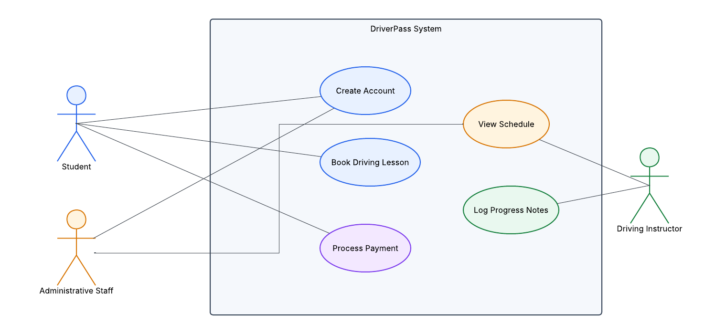

UML Activity Diagrams
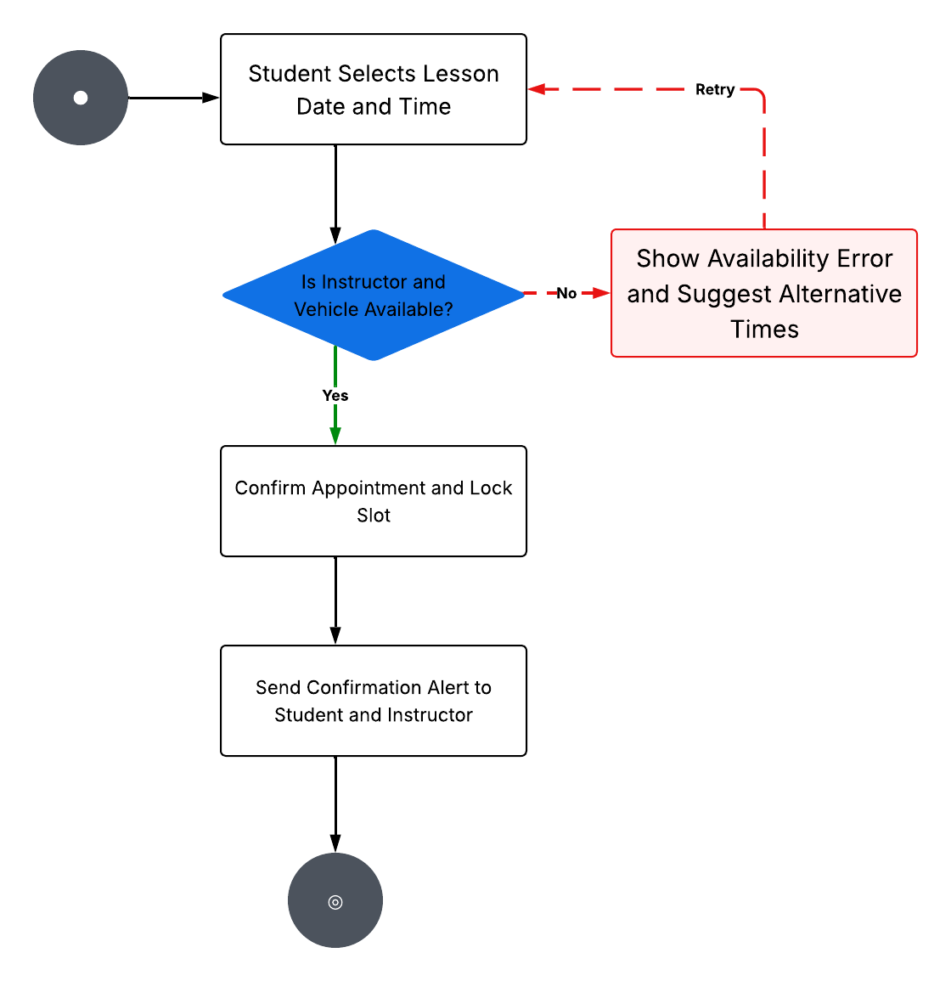

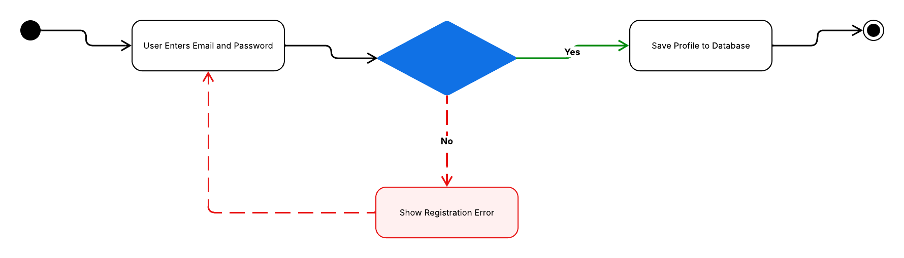

UML Sequence Diagram
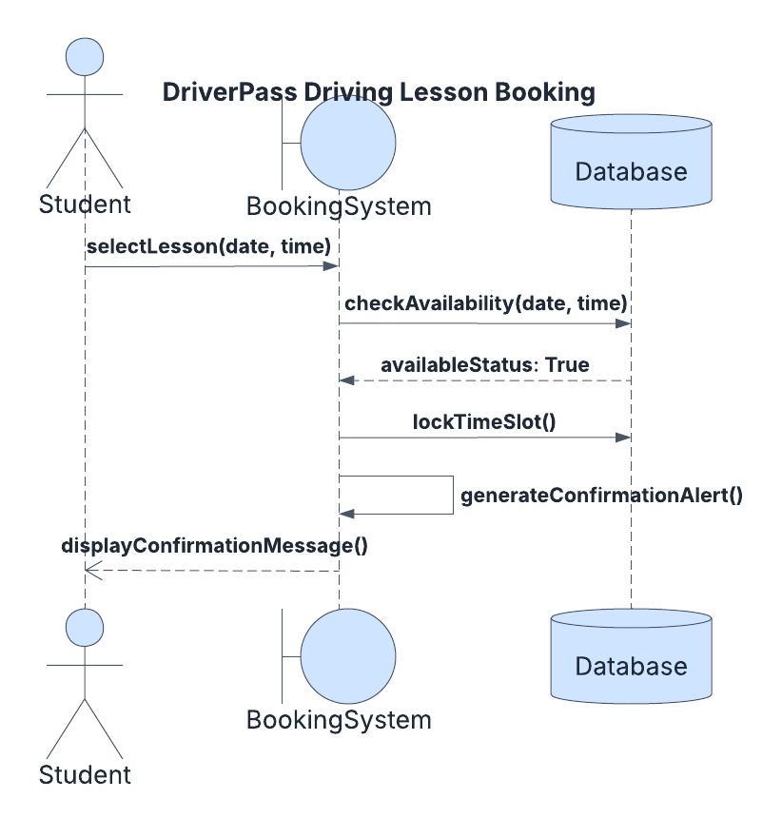

UML Class Diagram
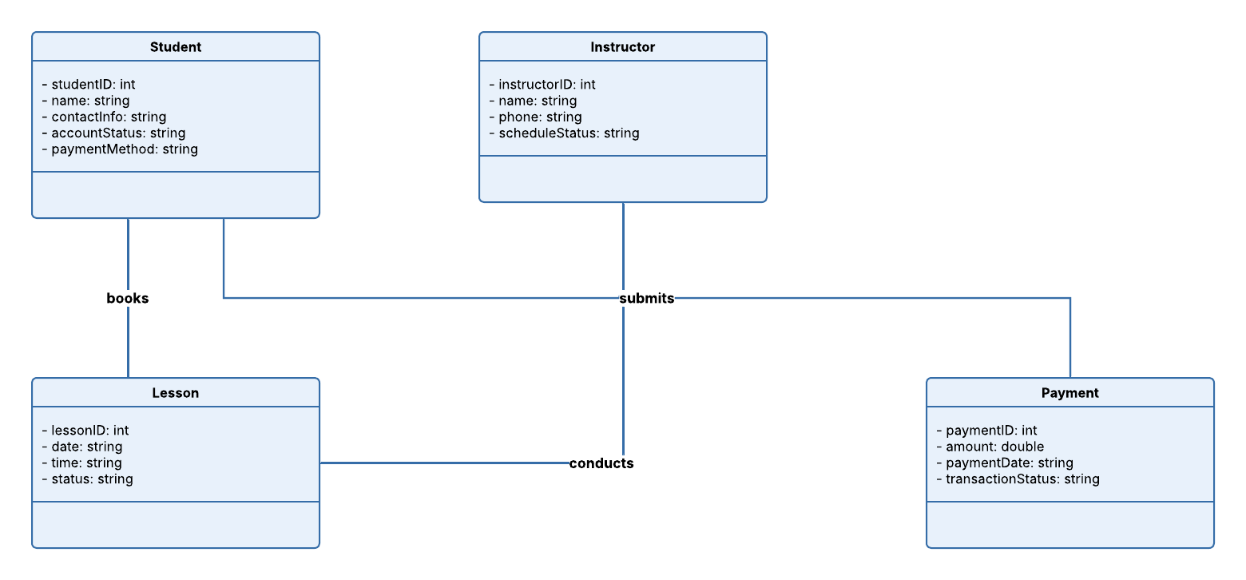

Technical Requirements
Based on the system diagrams, the DriverPass platform requires a secure, cloud-hosted setup to support everyday driving school operations.
- Hardware Requirements: The system runs entirely on remote cloud servers, which removes the need to buy or maintain physical server machines at the local office. Administrative staff will access the platform using standard office computers with a stable internet connection. Driving instructors on the road only need standard smartphones or tablets to view their schedules and document student progress.
- Software & Infrastructure Requirements: The platform relies on a scalable cloud database to securely hold business tracking information, including student records, instructor availability charts, lesson bookings, and transactions. An automated notification system links to this database to handle confirmation emails or text alerts. The system also integrates secure third-party payment gates to process credit card packages safely.
- Tools & Access: Users interact with the platform using common web browsing software, such as Google Chrome, Microsoft Edge, or Apple Safari. This browser-based access ensures that students, instructors, and office staff can log into the software instantly without downloading specialized installations or heavy apps.

